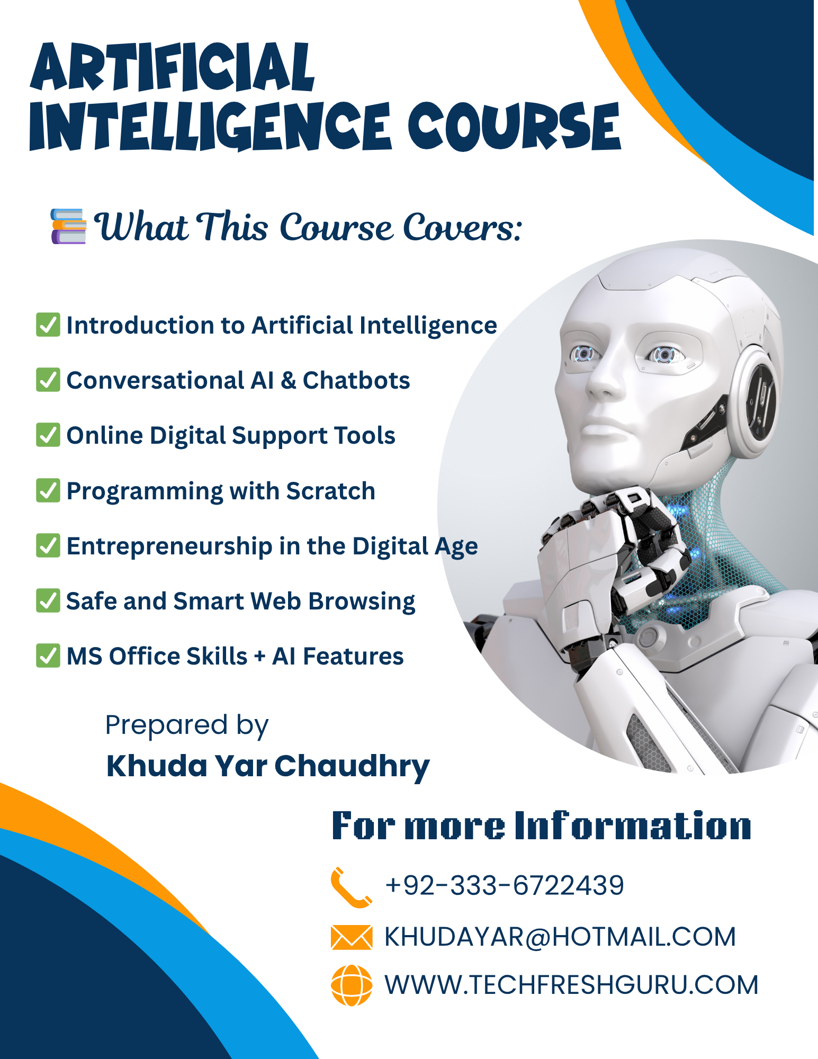

🧑‍💻 Hardware Requirements for Students

(For Artificial Intelligence Course 2025 – Classes 6 to 10)

To actively participate in this course, students will use the following computer hardware and devices:

✅ 1. Desktop Computer or Laptop

Processor: Core i3 or better

RAM: Minimum 4 GB (8 GB recommended)

Storage: 128 GB or more (SSD preferred)

Operating System: Windows 10 or higher

Purpose: For running Scratch, MS Office, web browsing, and using AI tools

✅ 2. Internet Connection

A stable internet connection is essential (Wi-Fi or cable)

Purpose: Accessing AI websites like ChatGPT, Google Translate, Canva, YouTube, etc.

✅ 3. Headphones with Microphone (Recommended)

Purpose: Listening to tutorials, using voice-based AI tools, participating in chatbot activities

✅ 4. Webcam (Built-in or External)

Purpose: Using AI tools for face recognition, video presentations, or online discussions

✅ 5. USB Flash Drive or Cloud Storage

Purpose: Saving Scratch projects, presentations, and other course files

✅ 6. Access to Printer (Optional but useful)

Purpose: Printing certificates, worksheets, and project materials when needed

**Table of content**

**Module 1: Introduction to Artificial Intelligence 4**

🧠 What is Artificial Intelligence? 4

🧰 Examples of AI in Daily Life: 4

📚 Why is AI Important? 4

🧠 History & Types of Artificial Intelligence 4

📖 History of Artificial Intelligence 4

🔍 Types of Artificial Intelligence 4

1. Narrow AI (Weak AI) 4

2. General AI (Strong AI) 5

3. Super AI 5

🌐 Real-world examples: Google Search, Education, Online Shopping etc. 6

🔍 1. Google Search 6

🧠 2. Education 6

🛒 3. Online Shopping 6

📱 4. Mobile Apps 6

💬 5. Social Media 6

🏥 6. Healthcare 6

🚀 7. Security 6

🏦 8. Banking & Finance 7

✈️ 9. Travel & Maps 7

🎮 10. Games 7

🏠 11. Smart Home Devices 7

🗣️ 12. Alexa / Siri / Google Assistant 7

🚗 13. Self-Driving Cars (Autonomous Vehicles) 7

# **Module 1: Introduction to Artificial Intelligence**

## **🧠 What is Artificial Intelligence?**

**Artificial Intelligence (AI)** is a branch of computer science that focuses on creating machines and software that can think, learn, and make decisions like humans. AI enables computers to solve problems, recognize speech, translate languages, and perform tasks that usually require human intelligence.

### **🧰 Examples of AI in Daily Life:**

* Google Assistant or Siri answering your questions
* YouTube suggesting videos you may like
* Face Unlock on mobile phones
* Google Maps showing the best route
* Online chatbots helping on websites

### **📚 Why is AI Important?**

* It makes our work easier and faster
* It helps doctors, engineers, teachers, and businesses
* It’s the future of technology — learning it now gives you a great head start!

## **🧠 History & Types of Artificial Intelligence**

### 📖 **History of Artificial Intelligence**

**1950s:** The idea of AI began when scientists started wondering, "Can machines think?" Alan Turing introduced the concept of a machine that could think like a human (Turing Test).

**1956:** The term "Artificial Intelligence" was officially used during a conference at Dartmouth College in the USA.

**1960s–1980s:** Early AI programs were created to solve math problems and play games like chess.

**1997:** IBM’s computer Deep Blue defeated world chess champion Garry Kasparov.

**2010s**–Present: AI is used in mobile phones, voice assistants, self-driving cars, healthcare, and social media.

### **🔍 Types of Artificial Intelligence**

### **1. Narrow AI (Weak AI)**

Narrow AI is built to perform only one task or a set of related tasks. It cannot think beyond what it is programmed to do.

**✔️ Real-World Examples:**

* Siri / Alexa / Google Assistant – Voice recognition and answering questions
* Face ID on iPhones – Facial recognition system
* Google Maps – Suggesting fastest routes using traffic data
* ChatGPT – Conversational AI trained for text responses
* Netflix / YouTube Recommendations – Suggesting videos or movies
* Email Spam Filters – Automatically detecting and moving spam emails
* Grammarly – Correcting grammar using AI
* Self-driving car software (Tesla Autopilot) – Drives based on rules and sensors

### **2. General AI (Strong AI)**

General AI can understand, learn, and perform any intellectual task that a human can. It has not been fully developed yet but is a goal for future research.

✔️ **Conceptual Examples (Still Under Development):**

* A robot teacher that can teach all subjects, answer emotional questions, and adapt to every student
* A home robot that cooks, cleans, cares for children, and also learns new tasks by observing
* Google DeepMind’s AlphaGo – Though Narrow AI, it started learning complex strategy patterns — a step toward General AI
* Advanced humanoid robots like Sophia (by Hanson Robotics) – Simulates conversation and expressions but still Narrow AI underneath

**🧪 Note: No true General AI exists yet — scientists and engineers are still trying to build it.**

### **3. Super AI**

Super AI is a theoretical future concept where machines will become more intelligent than humans in every field — emotionally, socially, and intellectually.

✔️ Imaginary / Future Examples:

* A medical AI that cures diseases instantly without human doctors
* AI governments making perfect decisions for countries
* AI writing better books, movies, music than humans
* Fully autonomous robot armies or self-aware AI systems (like in science fiction: Terminator, Iron Man’s JARVIS, Ultron, Ex Machina)

🧪 Note: Super AI does not exist today and raises many ethical questions.

## **🌐 Real-world examples: Google Search, Education, Online Shopping etc.**

### **🔍 1. Google Search**

What it does: Shows the most relevant results when you search something.

How AI works: It understands what you're trying to find and ranks billions of web pages using smart algorithms.

Example: When you type "Best science project for class 8", it shows the top websites using AI-powered ranking.

### **🧠 2. Education**

Khan Academy / Duolingo: Personalized learning suggestions based on performance.

Google Classroom: Uses AI to help organize tasks and give smart notifications.

Turnitin: Detects plagiarism in assignments using AI.

### **🛒 3. Online Shopping**

Amazon / Daraz: Recommends products based on your previous searches and purchases.

Chatbots on websites: Help you find products and answer FAQs instantly.

### **📱 4. Mobile Apps**

Snapchat / Instagram Filters: Detect faces and apply effects in real time.

Google Photos: Can find all pictures of a person by recognizing faces.

Voice Typing / Speech-to-Text: Convert your voice into text using AI (e.g., in WhatsApp or Docs).

### **💬 5. Social Media**

Facebook / Instagram: Suggests friends, tags people in photos using facial recognition.

TikTok / YouTube Shorts: Recommends videos based on your viewing behavior.

### **🏥 6. Healthcare**

AI-powered X-rays: Detect diseases like COVID-19 or cancer.

Fitness apps (e.g., Google Fit, Apple Health): Track health and give smart advice using AI.

### **🚀 7. Security**

CCTV with AI: Detects movement, recognizes faces, alerts unusual activity.

Fingerprint & Iris Scanning: Biometric security in offices and airports.

### **🏦 8. Banking & Finance**

Fraud Detection: AI watches for unusual transactions (e.g., unexpected ATM usage).

Chatbots in banks: Help with account details, transactions, and FAQs.

### **✈️ 9. Travel & Maps**

Google Maps / Waze: Suggests best routes, avoids traffic using live AI data.

Booking.com / AirBnB: Recommends hotels and flights as per your interests.

### **🎮 10. Games**

Chess vs. Computer: AI adjusts difficulty based on your level.

Mobile Games (e.g., PUBG bots): Use AI to simulate real players.

### **🏠 11. Smart Home Devices**

Smart Lights / AC / Fans (e.g., Philips Hue, Smart Life): Controlled by voice or schedule.

AI Security Systems: Ring Doorbells, smart locks that notify phone users.

### **🗣️ 12. Alexa / Siri / Google Assistant**

What it does: Listens to your voice and responds to commands or questions.

How AI works: Uses natural language processing (NLP) to understand and reply like a human.

Example: You say, “Play a song” or “What’s the weather?”, and it responds instantly.

### **🚗 13. Self-Driving Cars (Autonomous Vehicles)**

What it does: Drives a car without human help using sensors and AI.

How AI works: It detects roads, signs, people, and makes driving decisions.

Example: Tesla’s Autopilot system can change lanes, park, and even drive on highways by itself.